**ACTIONS ITEMS FOR SALES DATASET**

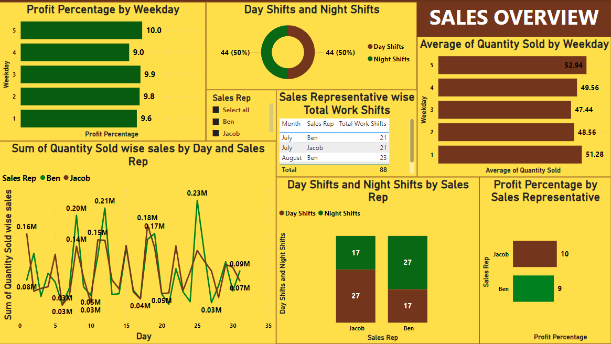

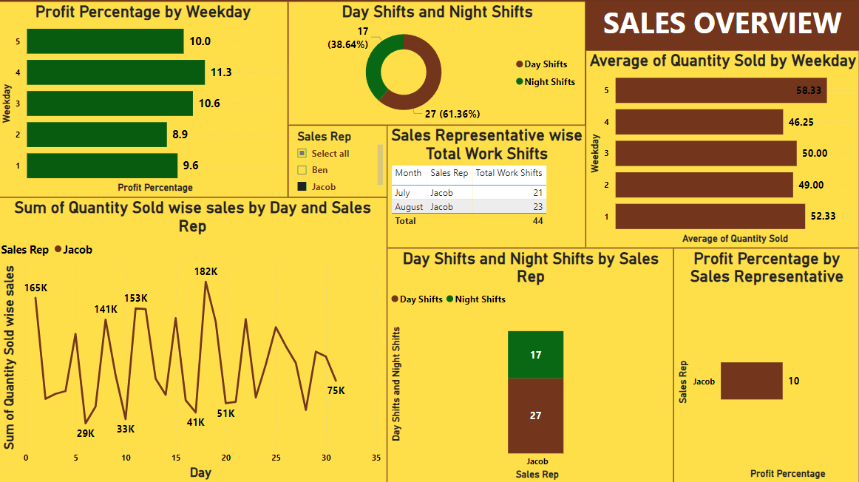**Jacob’s Performance**

**Ben’s Performance**

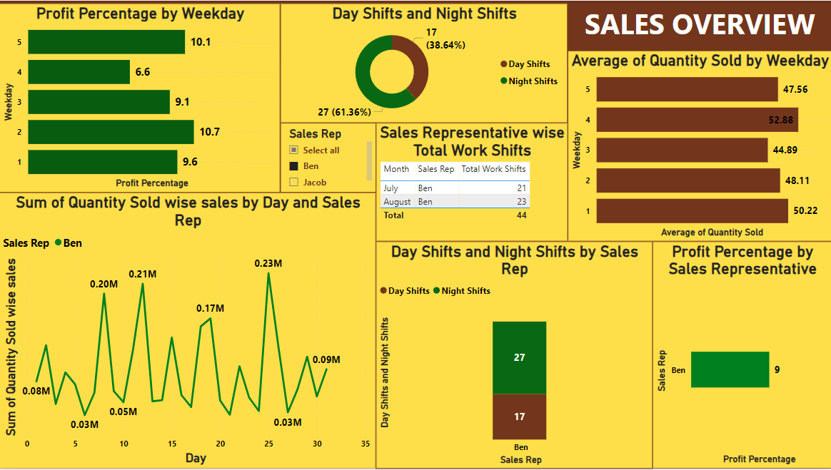

1. **Areas for further improvement in terms of business product sales-**

* **Weekday Performance:** The profit percentage varies across weekdays, with Friday showing the highest profit percentage (10%) and Thursday the lowest (9.0%). This indicates a potential area for improvement on Thursday's sales strategies.
* **Sales Representative Performance:** Ben and Jacob have different profit percentages, with Jacob showing a higher profit percentage (10%) compared to Ben (9%). Investigating the practices of Jacob could help improve Ben's performance.
* **Quantity Sold Trends:** There is a fluctuation in the sum of quantity sold. Identifying and addressing the factors contributing to low sales days could help smoothen these fluctuations**.**

1. **Predominant Work Shifts of Sales Representatives-**

* From the dashboards, it is evident that sales representatives have a balanced distribution between day shifts and night shifts.
* For Jacob, there is a noticeable trend towards night shifts in the second dashboard (61.36% night shifts), while for ben it is the same with day shifts.
* Both the representatives have equal number of working shifts.

1. **Additional Impacts on Business Product Sales Trends-**

* **Sales Trends by Day and Rep:** The fluctuating daily sales volumes indicate possible external factors affecting sales (e.g., market demand, promotions, etc.). Monitoring these factors and correlating them with sales data can help in planning more effective sales strategies.
* **Impact of Shifts:** The performance of night shifts vs. day shifts suggests that time of the day may impact sales. Further analysis could reveal whether certain products sell better during specific shifts.

**Action Items**

Based on the analysis, here are the action items for further improvement:

1. **Enhance Thursday Sales Strategies:**
   * Investigate and implement tactics to boost sales on Thursdays to match the performance of other weekdays.
2. **Leverage Successful Practices:**
   * Analyse Jacob’s sales strategies and techniques, and train Ben to adopt similar practices to enhance overall sales performance.
3. **Optimize Shift Schedules:**
   * Conduct a deeper analysis of sales performance during day and night shifts to optimize scheduling for maximum sales efficiency.
4. **Address Sales Fluctuations:**
   * Identify and mitigate factors contributing to the daily sales fluctuations to achieve a more stable sales trend.
5. **Boost Low-Performing Weekday Sales:**
   * Implement targeted promotions or sales activities on Mondays and other low-performing days to increase average quantity sold.